

# DNR Groundwater Technical Analysis Cross Section Tool Instructions

ArcGIS Pro

xx/xx/2024

## About

The cross sections created using this tool allow for visualization and comparison of well construction, well lithology, water level elevations, and pump settings. This toolbox has been constructed for use by DNR staff working on permit reviews and well interference investigations. The toolbox is meant to take the place of the DNR Groundwater Tool Add-In for ArcMap as the enterprise migrates to ArcGIS Pro. Each tool and its use are described below.

### Disclaimers

* The cross sections created using this tool use data from the County Well Index (CWI). The CWI database does contain errors and all information should be vetted prior to finalizing cross sections.
* Data obtained from the CWI database contains **Non-public information**.
  + Exact locations of public water supply wells - This includes all wells with the use codes MU, PC, PN, PP, and PS.
* Cross-sections created using Unverified well locations are not suitable for all applications.
* All cross sections that include geologic or hydrogeologic interpretations are required to be developed under a Professional Geoscientist (PG).

## Contents

About 1

Disclaimers 2

Contents 2

Versioning and Extensions 3

Starting A New Project 4

Add the DNR Cross Section Toolbox to ArcGIS Pro 5

Style Files 7

Sourcing Your Data 7

CWI Database 7

DEM rasters 8

Storing Your Data 8

Cross Section Traces 9

Using the Toolbox 10

1 Create Raster Profiles 10

Verified Wells Toolset 10

2 Get CWI Data 10

3 Clean CWI Data 10

4 Make Lixpy Diagrams 10

5 Create Conspy Diagrams 10

6a Create 2D Well Points 10

6b Create 2D SWL Points 10

6c Create 2D DPL Points 10

Unverified Wells Toolset 10

2 Get Unloc CWI Data 10

3 Clean Unloc CWI Data 10

4 Make Unloc Lixpy Diagrams 10

5 Create Unloc Conspy Diagrams 10

6a Create Unloc 2D Well Points 10

6b Create Unloc 2D SWL Points 10

6c Create Unloc 2D DPL Points 10

Editing Well Data 10

Edit well information 10

Edit well locations 10

Add New or Missing Wells 10

Manual Data Entry 10

Combining Files 10

Running Tools 10

Extras 10

7 Create Vertical Lines at Intersections 10

Formatting the Cross-sections 10

Non-public Information 10

Symbolize and label the wells in cross-section view 10

Format the well construction file 10

Combine verified and unverified well lithology files 10

Format the verified well lithology file 10

Format the unverified well lithology file 10

Add the static water level elevations 10

Add the pump setting information 10

Create polylines or polygons to illustrate lithology 10

Format gridlines and axes 10

Format the legend 10

Format the Cross Section PDF 10

## Versioning and Extensions

Before beginning, make sure you have:

* Installed ArcGIS Pro version 3.3 with Advanced license.
* Enabled the following ArcGIS Pro extensions.
  + Spatial Analyst
  + 3D Analyst

The latest version of ArcGIS Pro can be installed via Software Center.

To enable the ArcGIS Pro extensions, submit a ticket to MNIT GIS Team requesting that the extensions be enabled for your personal ArcGIS Pro license. A supervisor’s permission is not required.

## Starting A New Project

Each project/permit should have a separate ArcGIS Pro project (.aprx) for cross sections.

1. To create a new cross section project, open ArcGIS Pro. On the Start Screen, click on the “Start with another template” button on the right-hand side.

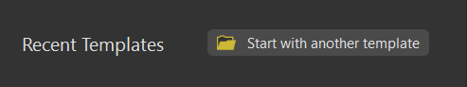

1. Navigate to “I:\EWR\_IMA\HGG\_HYDRO_GEO_GROUNDWATER\Tools\GIS\Pro_DNR_CrossSection_Tool\Templates” and select the “Pro_DNR_CrossSection_TemplateVX.aptx” file. Click OK.
2. A “Create a New Project” dialog box will open. Rename your project appropriately ([Permit #]-[Project Name]-XS Ex: 2001-0001-RainbowFarms-XS) and set your preferred location on a local drive but NOT buried deep in your file tree. The longer the file path, the more trouble you’ll have. Click OK.

* Your new project should have two maps and two layout options (letter and tabloid sizes) open as shown below.

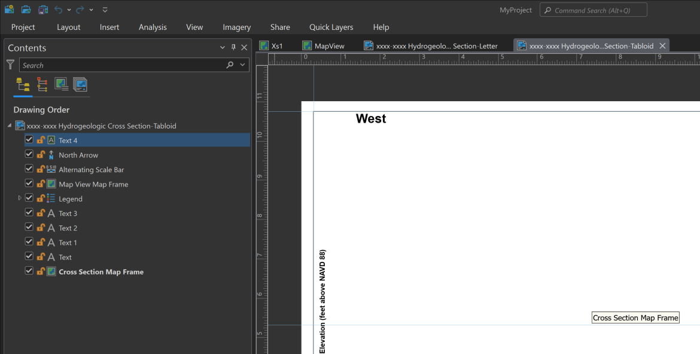

#### Layout Templates

Two layout templates are included in the project template by default. One is for letter-sized paper, the other for tabloid-sized paper. Choose whichever size works best and is approved by your PG.

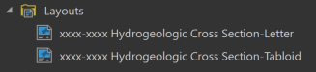

1. To use a layout, open the Table of Contents for the new layout window. Right click on the Map View Map Frame and select Properties.

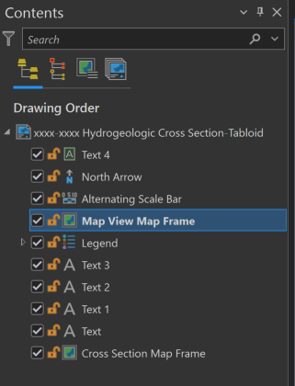

1. In the Element window, change the Map in the Map Frame drop down menu from “<None>” to “MapView”.

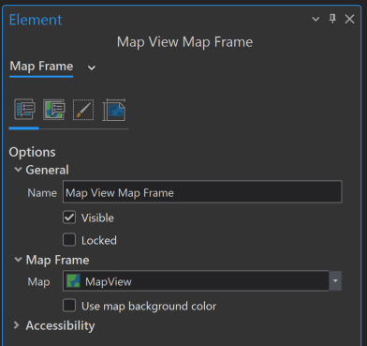

1. Repeat the same steps for the Cross Section Map Frame to populate the new layout with “Xs1”.

#### Grid Files

These files provide the grid line, polygon, and point label files for traditional cross section display, with the beginning of the cross section always at measure zero. These files should never be altered and are saved in the ‘grid2011.gdb’. If the file connection breaks, navigate to “I:\EWR\_IMA\HGG\_HYDRO_GEO_GROUNDWATER\Tools\GIS\Pro_DNR_CrossSection_Tool\Templates\GridFiles” to reconnect.

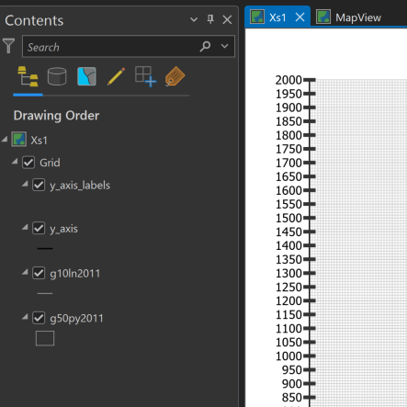

### Add the DNR Cross Section Toolbox to ArcGIS Pro

The DNR Cross Section Tools is a toolbox available for use in ArcGIS Pro by staff at DNR.

1. If the toolbox is not already available in your new ArcGIS Pro .aprx document, go to Catalog > Favorites > Add Item > Toolbox > Add Toolbox.
2. Navigate to “I:\EWR\_IMA\HGG\_HYDRO_GEO_GROUNDWATER\Tools\GIS\Pro_DNR_CrossSection_Tool” and select “DNR Cross Section Tools [most recent version].tbx” then click OK.
3. The toolbox should now be visible in both the Favorites and Project tabs of the Catalog. In the Project tab, expand the Toolboxes folder to view.

## Sourcing Your Data

### CWI Database

* **Wells with verified locations:**
  + The default data source for the tool scripts is a Spatial Database Engine (SDE) connection file saved on the I: drive. This SDE file is read-only, connects to the CWI database and updates daily automatically.
* **Wells with unverified locations:** 
  + A separate geodatabase on the DNR V: drive contains a point file with estimated well locations for unlocated wells. These estimated locations were generated by converting PLS data to UTM coordinates.
  + Estimated locations will likely need to be adjusted and the UTM coordinate fields updated to reflect the changes.
  + Data tables for these wells are obtained from the CWI database via the same SDE file as the Verified Location wells.

### DEM rasters

All rasters must be renamed WITHOUT special characters or spaces before running the toolbox tools.

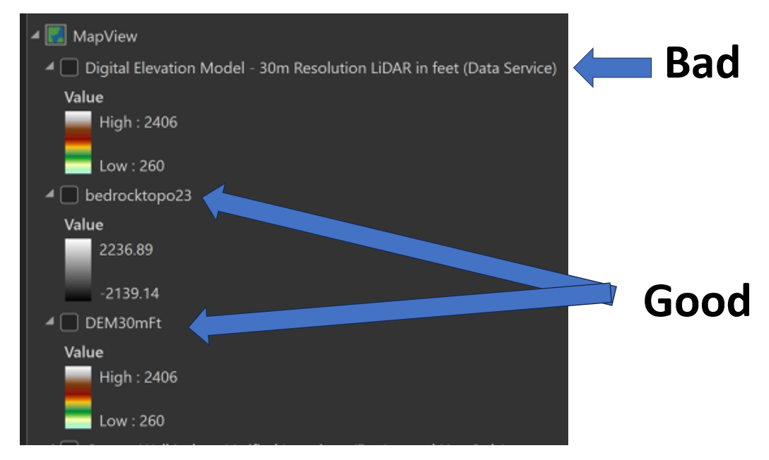

#### Surface Topography

* Best practice:
  + Use lower resolution DEMs (i.e. 30m) for land surface profiles for lines longer than 1-2 miles (Tool 1)
  + Use higher resolution DEMs (i.e. 1m or 3m) for extracting well surface elevations (Tool 2 in either verified or unverified toolsets)
    - The DEM used to extract well elevations MUST be named “dem”
* DEMs of any resolution from Quicklayers may be used as long as the following criteria are met:
  + The vertical values are in feet
  + The layer is a “Data Service” layer
  + The layer is renamed WITHOUT spaces or special characters after bringing it into your map
* 30-meter DEM example:
  + Add the “Digital Elevation Model - 30m Resolution LiDAR in feet (Data Service)” layer from Quicklayers to your Map View pane in ArcGIS Pro.
  + In the table of contents, right click the DEM layer and select Properties.
  + In the Layer Properties dialog box on the General tab, change the Name of the layer to “dem30mft” or similar and click OK.

#### Statewide Bedrock Topography

* For transects that span multiple counties, download a copy of the [MGS Bedrock topography DEM](https://www.arcgis.com/home/item.html?id=c59c0e1dd4d0491685a2fd4dfcc42d45) to your computer and add it to the MapView window.
  + If the above link breaks, go to this site: <https://mngs-umn.opendata.arcgis.com/pages/spatial-datasets>
  + Click on the D-Series Downloadable Data drop down menu and select D-4, Bedrock Topography.

**County Geologic Atlas Grids**

* If county atlas grids are available for your project area, you may want to include them in your cross section.
* Part A data is available on the I: drive at I:\EWR\_IMA\HGG\ATLAS\Author_Resources\Data\PartA
* Make sure the grids are in the correct projection (usually NAD 1983 UTM Zone 15N) before proceeding.

### Storing Your Data

Projects may be organized differently depending on cross section line (also referred to transect or cross section line throughout this document) orientation.

* Project data used across multiple cross sections should be stored in a general project geodatabase (ex: RainbowFarms.gdb).
  + Data examples:
    - mapview cross section line feature class containing all cross section lines for the project
    - mapview well points not available in CWI that are manually added
    - corresponding stratigraphy, construction, static water level, and drop pipe records for manually added wells

#### Non-overlapping lines

* If cross section lines and/or line buffers for a single project or site **DO NOT overlap**, all tool inputs and outputs may be stored in the same ArcGIS Pro project geodatabase. Multiple lines can be processed in batch, requiring each tool step to only be run once.

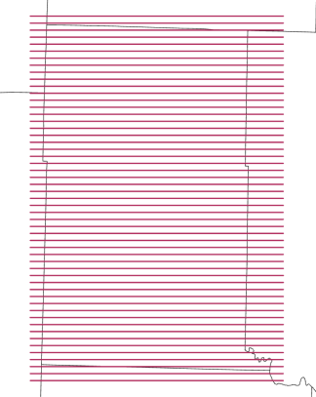

#### Overlapping lines

* If cross section lines or buffers for a single project or site **DO overlap**, it is best practice to store tool inputs and outputs in a separate geodatabase for each line. For example, for a project with 5 cross section lines, you will need at least 5 geodatabases. The tool automatically overwrites existing data if the file names have not been manually changed, so separation can help prevent accidental data loss. (ex: RainbowFarmsXs1.gdb, RainbowFarmsXs2.gdb, etc.).

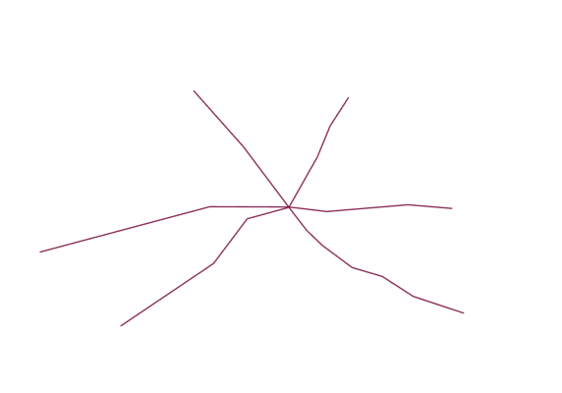

### Cross Section Lines

In this step you will prepare the cross section lines (a.k.a traces or transects) in the Map View data frame. These can be a straight lines or lines with many vertices that “zigzag” through the wells of interest.

##### Notes and Best practices

* The first location clicked on the map will be the left edge of the cross section the tool creates.
* Cross sections should always be digitized from West to East (if horizontal) or South to North (if vertical).
* It helps to begin digitizing your cross section line slightly to the West (or South) of the first well or

site of interest. This will prevent that feature from being covered up by the vertical axis displayed on the cross section using the DNR Groundwater Tool. The same is true for the last point digitized of the polyline.

* Every click of the cursor creates another vertex in the cross-section line.
* Each cross section line must be single part, or the tool will fail.
* Keep wells of interest within ½ mile (805 m) of the cross section line.
* Be wary of creating sharp right angles within a single line, as this can cause unexpected data omissions.

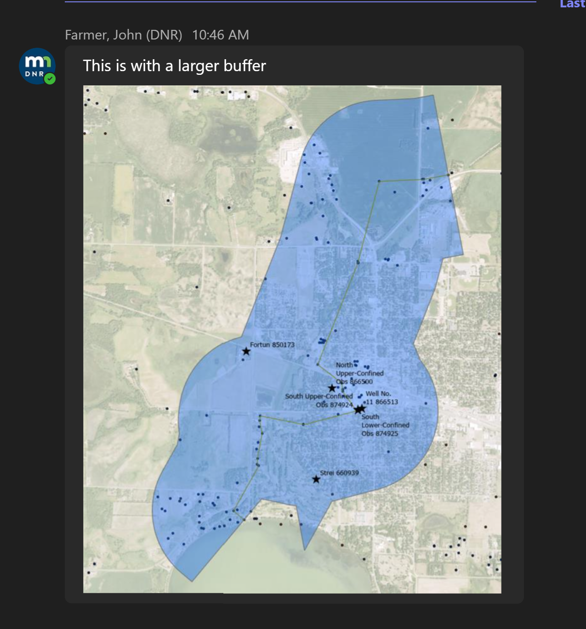 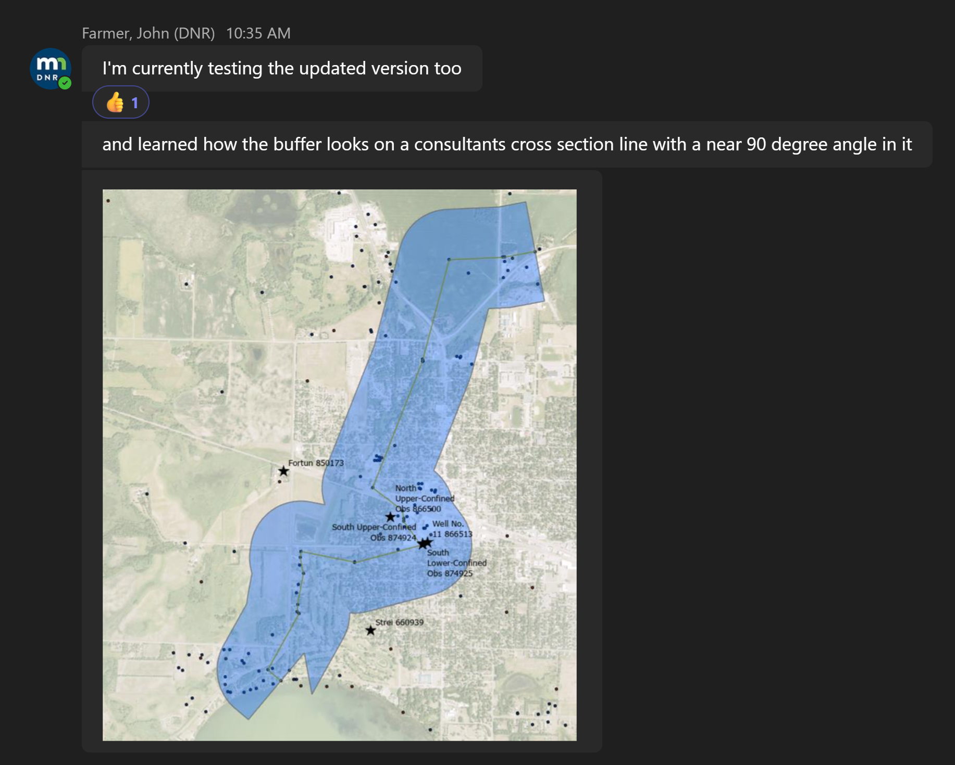

#### Import existing polyline files

If you already have cross section line in a .shp or feature class in another .gdb:

1. Import them into your cross section .gdb,
2. Add the required fields discussed below if they are not already present,
3. Remove any unnecessary fields that may be present from your newly imported feature class attribute table.
4. Review the “Notes and Best Practices” section and edit the imported lines as needed to meet those requirements.

#### Create a polyline feature class

1. To create a new feature class, open ArcCatalog and locate your cross section geodatabase.
2. Right‐click on the .gdb and select New Feature Class. Name it “xsln_mapview” and select “Line” from the Feature Class Type dropdown menu. Make sure both Geometric Properties boxes are unchecked. Click Next.

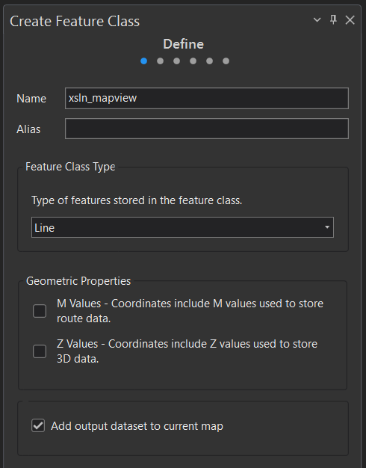

1. Add the following two fields: “xsec_id” and ‘’xsec_desc”, both with text data type. Click Next.
   1. Note: “xsec_desc” field is optional but encouraged.

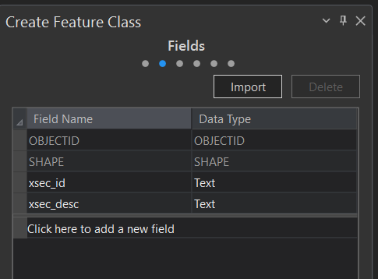

1. Select Projected Coordinate System NAD 1983 UTM Zone 15N. Click Finish.

#### Digitize the cross section lines

#### Draw lines

1. Open the MapView window and bring the xsln_mapview feature class into the Contents pane.
2. To digitize the cross-section lines, click on the Create button on the Edit ribbon. This will open the Create Features pane.
3. Click on the “xsln_mapview” file in the Create Features pane and then click on “Line” which should appear in a “Construction Tools” subpane. The cursor should now change to a cross hairs that allows you to digitize the polyline.
4. Click on the map to add a starting vertex for your polyline.
5. Straight polylines are created using only two vertices. Click once to start the polyline and then double‐click and the other end to finish digitizing the line. Lines for all cross sections can be stored in this feature class, so continue digitizing the remaining lines.
6. To create a non‐linear polyline with more than two vertices, continue clicking on the map, snapping to wells or sites of interest where appropriate.
7. When finished, click Save in the Edit ribbon.

#### Populate the cross-section line attributes

1. Right‐click on the “xsln_mapview” file in the Contents Pane. Select Attribute Table. Click on the Edit tab at the top of the project window to activate the editing ribbon.
2. Populate the xsec_id field with consecutive unique numbers, and the xsec_desc field with a brief description of the line’s orientation. Click Save.

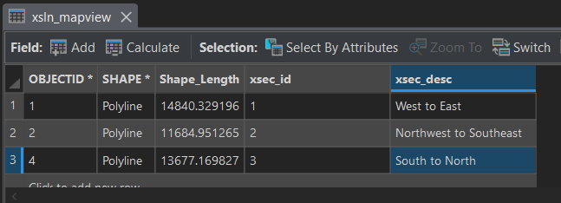

## Using the Toolbox

There are two toolsets in the 'DNR Cross Section Tools' toolbox: one uses only wells with verified locations, the other uses only wells with unverified locations. Some tools can be used with either verified or unverified wells – these are listed outside of the Verified and Unverified Toolsets (ex: 1 Create Raster Profiles). Best practice is to run each tool in numerical order.

### Before Beginning

* You must be connected to the network (I: and V: drives) for the tools to work!
* The output .gdb must be **manually refreshed** in the Catalog pane after running each tool to view output files. Output files must be manually added to the map from the output geodatabase.
  + Note: yes, this is annoying and inconvenient, but a software issue that doesn’t have an alternative solution at the time this document was written.

### 1 Create Raster Profiles

The primary purpose of this tool is to create elevation profiles for bedrock topography and surface topography, but the tool will draw a profile line on any raster surface.

#### Parameters

* Output geodatabase: gdb for saving output files.
* Input raster(s): tool will accept any raster surfaces, but this tool is generally used for creating bedrock and surface topo profiles
  + Enter all the rasters you would like to create profiles (the tool can extract multiple raster profiles at a time for multiple cross section lines).
  + **Vertical units MUST be in feet.**
* Cross section line file (mapview): cross section lines in map view.
  + Note that unless a single line is selected in map view, a single output file (ex: DEM30mft_profiles2d_25x) will contain 30m DEM profiles for all xslns put into the tool, as shown below. Green lines show land surface profiles for each of the 3 cross-section lines in the input file. Purple lines show bedrock profiles for each of the 3 cross-section lines in the input file.
  + To produce profiles for a single line in xsln_mapview, make sure the line is selected before running the tool.
* Cross section ID field: xsec_id or field in xsln that contains unique cross section number. MUST BE text data type.
* Vertical exaggeration factor: Must be ≥ 1. Common values to use are 25, 50, or 100. If you change this value, be sure to press the “Enter” key before running the tool. After running the tool, verify in the Geoprocessing History window that the correct value was used.
* Merge output files: check to save all output profiles to a single feature class, instead of individual feature classes for each raster.

#### Output

* For each raster, tool will create:
  + 2d profile in cross section view:
    - Without Merge option: Files are automatically named “[RasterName]_profiles2d_[VE value]x”
    - With Merge option: File is automatically named "all_profiles_2d_[VE value]x"

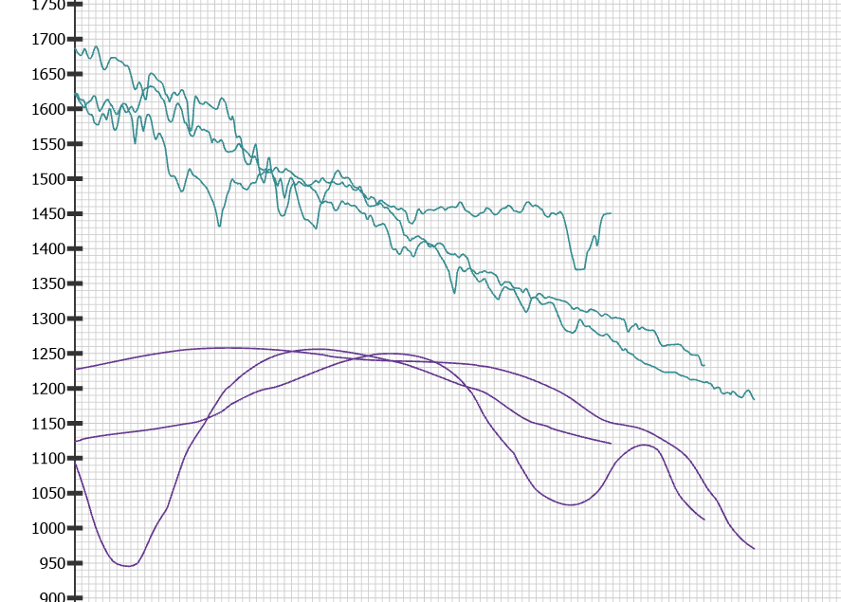

##### Troubleshooting

* If the tool fails immediately, make sure you are viewing the Map View map window.
* If it fails with errors stating “dataset does not exist or is not supported” or “the input name contains invalid characters”, rename your input rasters as described in the “Sourcing Your Data” section of this document.
* If xsln file has an **unknown spatial reference**, cancel the tool and define the projection for the xsln file.
* If xsln file is **multipart**, cancel the tool and run multipart to single part.
* If any files do not get deleted and the tool crashes, **make sure there are no lock files** and try again.
* If xsec_id **field is blank** in any features, tool will crash. Fill in the data or delete.
* If xsec_id field is **numeric data type** instead of text, the “where” clause will not work and tool will not write and output 2D geometry. Create new xs_id field with text data type.
* If the output has **empty output fields**, shake your fist angrily at ESRI. Close your project, restart your computer, and try again.

## Verified Wells Toolset

**Warning!**

* These tools will overwrite any existing files with the same name.
* This toolset replaces all CWI elevations with elevations extracted from a DEM.

### 2 Get CWI Data

This tool gathers CWI wells with verified locations within the specified buffer distance of each xsln. The tool then retrieves the corresponding stratigraphy/lithology, static water level, drop pipe length, and construction data for each well. In addition, DEM elevations are extracted for each well point and added to each dataset.

**If xslns overlap or have overlapping buffer zones, this tool must be run separately for each xsln. Highlight a single xsln before running this tool.**

**If xslns do not overlap and do not have overlapping buffer zones, all xslns may be run in batch.**

#### Parameters

* Output geodatabase: gdb for saving output files. Use the project’s default geodatabase.
* Cross section line file (mapview): cross section line(s) in map view.
* Buffer distance (in meters):
  + Rule of thumb: Don’t use any greater distance than ½ mile or 805 meters.
* Land Surface DEM: Use the finest resolution DEM available. Values must be in feet. This file must be renamed to “dem” in the “Contents” pane or tool will fail.
* Include strat data: box is checked by default. If you do NOT want to retrieve stratigraphy data, uncheck the box.
* Include drop pipe data: box is checked by default. If you do NOT want to retrieve drop pipe data, uncheck the box.

#### Output

* Wwpt: mapview well points within the buffer area for all xslns
* Xsln_buffer: polygon showing buffer area around each xsln
* Swl: mapview well points with static water data, if available
* Data tables for wwpt wells:
  + cons: construction data
  + strat: stratigraphy and lithology data (only if box is checked)
  + dpl: drop pipe length (only if box is checked)

##### Troubleshooting

* If it fails because “input dataset does not exist or is not supported”, open the script and make sure that all paths to the SDE are correct.
* After running the tool, review the well points to make sure none are missing. If new or missing wells (that are NOT in the unverified well dataset) need to be added, see instructions below.
* If tool fails to open, verify that you are using the appropriate version of ArcGIS Pro.

### 3 Clean CWI Data

This tool cleans and formats the stratigraphy, construction, static water level and drop pipe CWI data by removing unnecessary fields and records, adding and calculating required fields, and converts the drop_pipe table to a point file.

#### Parameters

* Output geodatabase: gdb for saving output files. Use the project’s default geodatabase.
* construction table (cons): construction data table produced by Get CWI Data tool.
* Drop pipe table (dpl): drop pipe data table produced by Get CWI Data tool.
* Static water level points (swl): static water level mapview points produced by Get CWI Data tool.
* Strat table (strat): stratigraphy table produced by Get CWI Data tool.

#### Output

* cons_clean: construction data table with only casing, screen, and open hole data (grout records as wells as extra fields removed)
* dpl_clean: drop pipe mapview point feature class with extra fields removed
  + Note: records without dropp_len values are included in the output table
* swl_clean: swl mapview point feature class with extra fields removed and elevations calculated from DEM values.
* strat_clean: stratigraphy table with extra fields removed and elevations calculated from DEM values.

##### Troubleshooting

* WARNING: “Certain rows set to NULL due to error while evaluating python expression: TypeError: unsupported operand type(s) for -: 'float' and 'NoneType'”
  + Translation: Record in ‘to_depth’ field is null, resulting in null values in ‘elev_bot’ field.
  + Fix: populate null values in ‘from_depth’ and ‘to_depth’ fields in cons table, then rerun tool.

### 4 Make Lixpy Diagrams

This tool creates well stick diagrams (lixpys) based on a stratigraphy and lithology table (strat), well point location feature class (wwpt), and mapview cross section line file (xsln).This tool may take a few minutes depending on number of strat records.

#### Parameters

* Output geodatabase: gdb location for saving output files.
* Stratigraphy table (Strat_clean): gdb table that contains cleaned stratigraphy and lithology data.
* Well point file (wwpt): point feature class that contains well locations.
* Cross section line file (mapview) (xsln_mapview): cross section lines in map view.
* Cross section ID field (xsec_id): field in xsln that contains cross section number.
* Cross section ID field in well point file (xsec_id): field in wwpt that contains cross section number that matches number in xsln file.
* Well ID field in stratigraphy table (relateid or wellid): field that is used to relate strat table and wwpt file to each other.
* Well id field in well point file (relateid): field that is used to relate to strat table.
* Buffer distance (in meters): must match value used in Get CWI Data tool.
* Vertical exaggeration: must match value used in Create Raster Profiles tool.
* Well stick width: default value is 0.5, can be increased up to 5 for longer cross-sections.

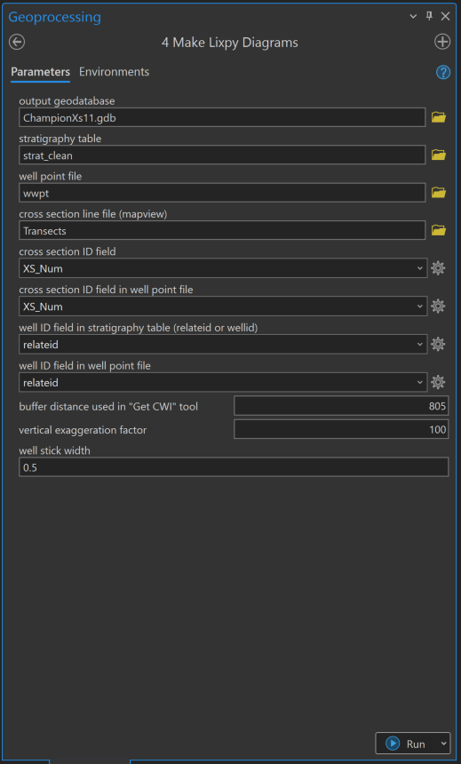

#### Output

* Lixpy polygons in 2d (xsec view) – used to display lithology

##### Troubleshooting

* If it runs really **slowly**, make sure all data is on a local drive and try again.
* If xsln file has an **unknown spatial reference**, cancel the tool and define the projection for the xsln file.
* If xsln file is **multipart**, cancel the tool and run the “multipart to single part” tool.
* If correct **fields don’t exist**, cancel the tool and change the field names (not alias) to match the error message. Calculate fields as needed.
* If **xsec_ids in strat table/well points don’t match cross section file**, the attribute data will need to be modified until they match.

### 5 Create Conspy Diagrams

This tool creates well stick diagrams (conspys_2D_poly) based on a cleaned well construction table (cons_clean), well point location feature class (wwpt), and mapview cross section line file (xsln_mapview).This tool may take some time depending on number of construction records.

Before using this tool, review the “cons_clean” table for missing or inaccurate data. Be sure to recalculate the [elev_top] and [elev_bot] fields after making any changes to the [from_depth] or [to_depth] fields.

#### Parameters

* Output geodatabase: gdb location for saving output files.
* Cleaned construction table: gdb table that contains cleaned construction data.
* Well point file (wwpt): point feature class that contains well locations.
* Mapview cross section line file (xsln_mapview): cross section lines in map view.
* Cross section ID field: field in xsln that contains cross section number.
* Well point cross section ID field: field in wwpt that contains cross section number that matches number in xsln file.
* construction table well ID field: field that is used to relate construction table and wwpt file to each other (relateid)
* Well point well id field: field that is used to relate to construction table (relateid).
* Buffer distance: must match value used in Get CWI Data tool.
* Vertical exaggeration: must match value used in Create Raster Profiles tool.
* Well stick width: default value is 0.5, can be increased up to 5 for longer cross-sections. Best practice is to match value used in Make Lixpy Diagram tool.

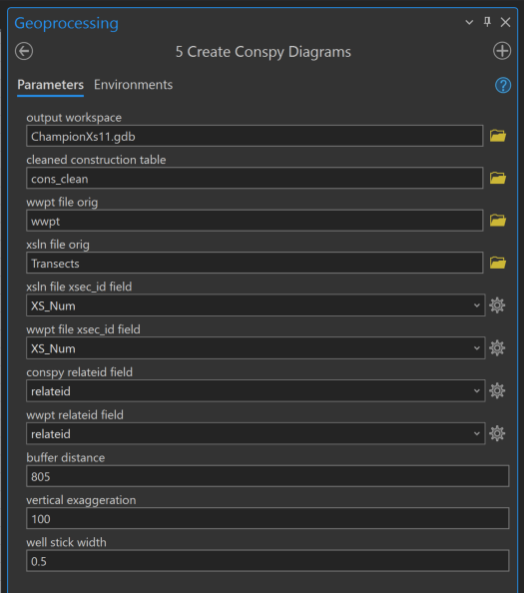

#### Output

* Conspy polygons in 2d (xsec view) – used to display construction type (casing, open hole, screen).

##### Troubleshooting

* If it runs really **slowly**, make sure all data is on a local drive and try again.
* If xsln file has an **unknown spatial reference**, cancel the tool and define the projection for the xsln file.
* If xsln file is **multipart**, cancel the tool and run multipart to single part.
* If correct **fields don’t exist**, cancel the tool and change the field names (not alias) to match the error message. Calculate fields as needed.
* If **xsec_ids in construction table/well points don’t match cross section file**, the attribute data will need to be modified until they match.
* If the well casings or well screens do not appear, you will need to go back and repeat some of the earlier steps.
  + Open the cons_clean table and manually add the casing, and screen information in the appropriate fields.
* Rerun the Create Conspy Diagrams tool to create a new set of conspy well stick files

### 6a Create 2D Well Points

This tool creates 2D well points at ground elevation in cross-section view based on a well point location feature class (wwpt), and mapview cross section line file (xsln).

#### Parameters

* Output geodatabase: gdb location for saving output files.
* Well point file (wwpt): point feature class that contains well locations.
* Mapview cross section line file (xsln_mapview): cross section lines in map view.
* Cross section ID field: field in xsln that contains cross section number.
* Well point cross section ID field: field in wwpt that contains cross section number that matches number in xsln file.
* Well point well id field: field that is used to relate to construction table (related).
* Buffer distance: must match value used in Get CWI Data tool.
* Vertical exaggeration: must match value used in Create Raster Profiles tool.
* Well label field in well point file: field named “well_label”, must be Text type. Intended to provide unique numbers without leading zeros for labeling purposes.

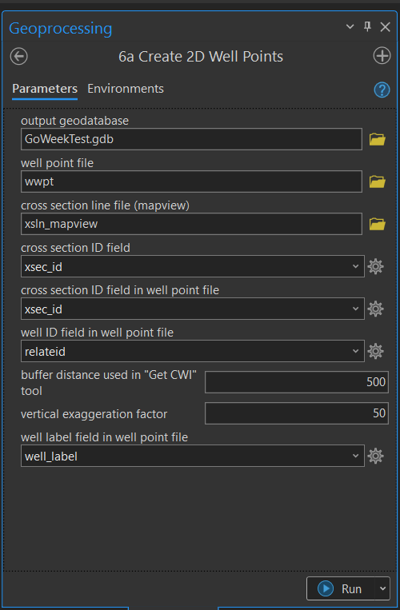

#### Output

* Wwpt_2d_xsecview: point file for cross-section viewing

##### Troubleshooting

* Well points are appearing over blank spaces. Check that lithology and construction data exists for these wells.

### 6b Create 2D SWL Points

This tool creates 2D points at static water level (SWL) elevations in cross-section view based on a swl well point location feature class (swl_clean), and mapview cross section line file (xsln_mapview).

#### Parameters

* Output geodatabase: gdb location for saving output files.
* SWL well point file (swl_clean): point feature class that contains well locations and swl elevations.
* Mapview cross section line file (xsln_mapview): cross section lines in map view.
* Cross section ID field: field in xsln_mapview that contains cross section number.
* SWL well point cross section ID field: field in swl_clean that contains cross section number that matches number in xsln file.
* Well id field in SWL well point file: field that is used to relate to swl table (relateid).
* Buffer distance: must match value used in Get CWI Data tool.
* Vertical exaggeration: must match value used in Create Raster Profiles tool.

#### Output

* swl_2d_xsecview: point file for cross-section viewing

##### Troubleshooting

* Water level points are missing. Check that there are SWL records with elevations (meas_elev) for these wells.
* Water level points are in the incorrect locations. Check that you used the correct input files.
* **ERROR 000732:** cross section line file (mapview): Dataset xsln_mapview does not exist or is not supported. Make sure MapView frame is visible and contains xsl_mapview when tool is run.

### 6c Create 2D DPL Points

This tool creates 2D well points at pump or drop pipe (DPL) elevations in cross-section view based on a dpl well point location feature class (dpl_clean), and mapview cross section line file (xsln_mapview).

#### Parameters

* Output geodatabase: gdb location for saving output files.
* DPL well point file (dpl_clean): point feature class that contains well locations and drop pipe lengths.
* Mapview cross section line file (xsln_mapview): cross section lines in map view.
* Cross section ID field: field in xsln that contains cross section number.
* DPL well point cross section ID field: field in dpl_clean that contains cross section number that matches number in xsln file.
* Well id field in DPL well point file: field that is used to relate to dpl table (relateid).
* Buffer distance: must match value used in Get CWI Data tool.
* Vertical exaggeration: must match value used in Create Raster Profiles tool.

#### Output

* dpl_2d_xsecview: point file for cross-section viewing.

##### Troubleshooting

* Well points are missing. Check that there are DPL records for these wells.

## Unverified Wells Toolset

### 2 Get Unloc CWI Data

This tool gathers CWI wells with unverified locations within the specified buffer distance of each xsln. The tool then retrieves the corresponding stratigraphy/lithology, static water level, drop pipe length, and construction data for each well. In addition, DEM elevations are extracted for each well point and added to each dataset.

**If xslns overlap or have overlapping buffer zones, this tool must be run separately for each xsln. Highlight a single transect before running this tool.**

**If xslns do not overlap and do not have overlapping buffer zones, all xslns may be run in batch.**

#### Parameters

* Output gdb location: gdb for saving output files. Use the project’s default geodatabase.
* Cross section line file (mapview) (xsln): cross section lines in map view. MUST have " xsec_id" field.
* Buffer distance: must match value used in Get CWI Data tool
  + Don’t use any greater distance than ½ mile or 805 meters.
* DEM (land surface) must be:
  + 1 or 3 meter resolution
  + The vertical values are in feet
  + A “Data Service” layer
  + **Renamed to exactly “dem”**

#### Output

* Wwpt_unloc: mapview well points within the buffer area for all xslns
* Xsln_buffer: polygon showing buffer area around each xsln
* Data tables for wwpt_unloc wells:
  + Cons_unloc: construction data, if available
  + Strat_unloc: stratigraphy and lithology data, if available
  + Dpl_unloc: drop pipe length, if available
  + Swl_unloc: static water level data, if available

##### Troubleshooting

* If it fails because “input dataset does not exist or is not supported”
  + First, make sure you are connected to the V: drive.
* Tool will fail if there are no unverified wells within buffer distance
  + Increase buffer distance to grab wells of interest, then remove extra wells from XX_unloc tables

### 3 Clean Unloc CWI Data

This tool cleans and formats the unlocated well construction, static water level, and drop pipe CWI data by removing unnecessary fields and records and converts the swl_unloc and dpl_unloc tables to point files.

#### Parameters

* Output workspace (gdb location): gdb for saving output files. Use the project’s default geodatabase.
* Construction Table (cons_unloc) : construction data table produced by Get Unloc CWI Data tool.
* Drop pipe table (dpl_unloc) : drop pipe data table produced by Get Unloc CWI Data tool.
* Static Water Level Table (swl_unloc) : static water level data table produced by Get Unloc CWI Data tool.
* Strat Table (strat_unloc) : strat/lith table produced by Get Unloc CWI Data tool.

#### Output

* cons_unloc_clean: construction data table with only casing, screen, and open hole data (grout records as wells as extra fields removed)
* strat_unloc_clean: strat data table with required fields added, extras removed
* dpl_unloc_clean: drop pipe mapview point feature class
  + Note: records without dropp_len values are included in the output table
* swl_unloc_clean: static water level mapview point feature class

##### Troubleshooting

* WARNING: “Certain rows set to NULL due to error while evaluating python expression: TypeError: unsupported operand type(s) for -: 'float' and 'NoneType'”
  + Translation: Record in ‘to_depth’ field is null, resulting in null values in ‘elev_bot’ field.
  + Fix: populate null values in ‘from_depth’ and ‘to_depth’ fields in cons table, then rerun tool.

### 4 Make Unloc Lixpy Diagrams

This tool creates well stick diagrams (lixpys) for unverified location wells based on a stratigraphy and lithology table (strat, lith), well point location feature class (wwpt_unloc), and mapview cross section line file (xsln).This tool may take some time depending on number of strat records.

#### Parameters

* Output geodatabase: gdb location for saving output files.
* Stratigraphy Table (strat_unloc_clean): gdb table that contains cleaned stratigraphy and lithology data.
* Well point file (wwpt_unloc): point feature class that contains unverified well locations.
* Cross section line file (Mapview) (xsln_mapview): cross section lines in map view.
* Cross section ID field (xsec_id): field in xsln that contains cross section number.
* Cross section ID field in well point file (xsec_id): field in wwpt_unloc that contains cross section number that matches number in xsln file.
* Well ID field in stratigraphy table (related): field that is used to relate strat table and wwpt_unloc file to each other.
* Well ID field in well point file (related): field that is used to relate to strat table.
* Buffer distance used in “Get CWI” tool: must match value used in Get CWI Data tool.
* Vertical exaggeration factor: must match value used in Create Raster Profiles tool.
* Well stick width: default value is 0.5, can be increased up to 5 for longer cross-sections

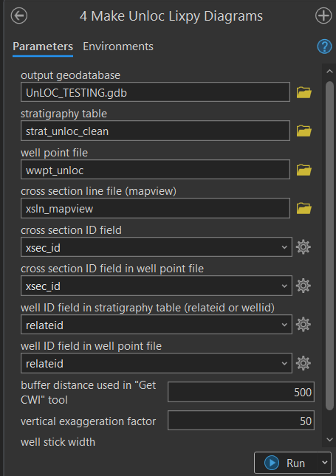

#### Output

* UnlocLixpy polygons in 2d (xsec view) – used to display lithology

##### Troubleshooting

* If it runs really **slowly**, make sure all data is on a local drive and try again.
* If xsln file has an **unknown spatial reference**, cancel the tool and define the projection for the xsln file.
* If xsln file is **multipart**, cancel the tool and run multipart to single part.
* If correct **fields don’t exist**, cancel the tool and change the field names (not alias) to match the error message. Calculate fields as needed.
* If **xsec_ids in strat table/well points don’t match cross section file**, the attribute data will need to be modified until they match.

### 5 Create Unloc Conspy Diagrams

This tool creates unverified well stick diagrams (conspys) based on a well construction table (cons), well point location feature class (wwpt), and mapview cross section line file (xsln).This tool make take some time depending on number of construction records.

#### Parameters

* Output workspace (gdb): geodatabase location for saving output files.
* Cleaned unloc construction table (cons_unloc_clean): gdb table that contains cleaned construction data.
* Unloc wwpt file orig (wwpt_unloc): point feature class that contains well locations.
* xsln line file (xsln_mapview): cross section lines in map view.
* xsln file xsec_id field (xsec_id): field in xsln that contains cross section number.
* wwpt file xsec_id field: field in wwpt that contains cross section number that matches number in xsln file.
* conspy relateid field: field that is used to relate construction table and wwpt file to each other
* wwpt relateid field (RELATEID): field that is used to relate to construction table.
* Buffer distance: must match value used in Get CWI Data tool.
* Vertical exaggeration: must match value used in Create Raster Profiles tool.
* Well stick width: default value is 0.5, can be increased up to 5 for longer cross-sections. Must match value used in Make Lixpy Diagram tool.

#### Output

* Unloc Conspy polygons in 2d (xsec view) – used to display lithology

##### Troubleshooting

* If it runs really **slowly**, make sure all data is on a local drive and try again.
* If xsln file has an **unknown spatial reference**, cancel the tool and define the projection for the xsln file.
* If xsln file is **multipart**, cancel the tool and run multipart to single part.
* If correct **fields don’t exist**, cancel the tool and change the field names (not alias) to match the error message. Calculate fields as needed.
* If **xsec_ids in construction table/well points don’t match cross section file**, the attribute data will need to be modified until they match.
* If the well casings or well screens do not appear, you will need to go back and repeat some of the earlier steps.
  + Open the cons_unloc_clean table and manually add the casing, and screen information in the appropriate fields.
  + Rerun the Create Conspy Diagrams tool to create a new set of conspy well stick files

### 6a Create Unloc 2D Well Points

This tool creates 2D well points for unverified wells at ground elevation in cross-section view based on a well point location feature class (wwpt), and mapview cross section line file (xsln).

#### Parameters

* Output geodatabase: gdb location for saving output files.
* Unloc well point file (wwpt_unloc): point feature class that contains well locations.
* Cross section line file (xsln_mapview): cross section lines in map view.
* Cross section ID field (xsec_id): field in xsln that contains cross section number.
* Cross section ID field in well point file (xsec_id): field in wwpt that contains cross section number that matches number in xsln file.
* Well ID field in well point file (related): field that is used to relate to construction table.
* Buffer distance: must match value used in Get CWI Data tool.
* Vertical exaggeration: must match value used in Create Raster Profiles tool.
* Well stick width: default value is 0.5, can be increased up to 5 for longer cross-sections. Must match value used in Make Lixpy Diagram tool.
* Well label field in well point file: field named “WELL_LABEL”, must be Text type. Intended to provide unique numbers without leading zeros for labeling purposes.



#### Output

* Wwpt_unloc_2d_xsecview: point file for cross-section viewing

##### Troubleshooting

* Well points are appearing over blank spaces. Check that lithology and construction data exists for these wells.

### 6b Create Unloc 2D SWL Points

This tool creates 2D points at static water level (SWL) elevations for unverified wells in cross-section view based on a swl well point location feature class (swl_unloc), and mapview cross section line file (xsln).

#### Parameters

* Output geodatabase: gdb location for saving output files.
* Unloc SWL well point file (swl_unloc_clean): mapview point feature class that contains unverified well locations and swl elevations.
  + Make sure the
* Cross section line file (xsln_mapview): cross section lines in map view.
* Cross section ID field (xsec_id): field in xsln that contains cross section number.
* Cross section ID field in SWL well point file (xsec_id): field in swl_unloc that contains cross section number that matches number in xsln file.
* Well id field in SWL well point file (related): field that is used to relate to swl table.
* Buffer distance: must match value used in Get CWI Data tool.
* Vertical exaggeration: must match value used in Create Raster Profiles tool.



#### Output

* swl_unloc_2d_xsecview: point file for cross-section viewing

##### Troubleshooting

* Well points are missing. Check that there are SWL records for these wells and the measurement values are not null or zero.

### 6c Create Unloc 2D DPL Points

This tool creates unverified 2D well points at pump or drop pipe (DPL) elevations in cross-section view based on a dpl well point location feature class (dpl_unloc), and mapview cross section line file (xsln).

#### Parameters

* Output geodatabase: gdb location for saving output files.
* DPL well point file (dpl_unloc_clean): point feature class that contains well locations and drop pipe lengths.
* Cross section line file (mapview) (xsln_mapview): cross section lines in map view.
* Cross section ID field (xsec_id): field in xsln that contains cross section number.
* Cross section ID field in DPL well point file (xsec_id): field in dpl_unloc that contains cross section number that matches number in xsln file.
* Well id field in DPL well point file (related): field that is used to relate to dpl table.
* Buffer distance: must match value used in Get CWI Data tool.
* Vertical exaggeration: must match value used in Create Raster Profiles tool.

#### Output

* dpl_unloc_2d_xsecview: point file for cross-section viewing.

##### Troubleshooting

* Well points are missing. Check that there are DPL records for these wells.

## Editing Well Data

**Only make these changes AFTER running the Get CWI tool.**

### Edit well information

1. In some instances, information contained in CWI may be inaccurate. Information in the attribute table of the “wwpt” file can be updated using the **Edit** ribbon. Double click in the attribute table cell you want to edit, make your edits, and click Save on the Edit ribbon when finished.

### Edit well locations

1. If it is determined that a well is inaccurately located, the well point can be moved in the “Map View” data frame. Start by clicking on the wwpt layer, then open the Edit ribbon.
2. Click on the well point of interest using the **Selection** tool to highlight that point. Then click on and drag the well point to the desired location. Save edits when done.
3. While the well point has moved in the Map View, the associated coordinates have not been updated in the “wwpt” attribute table. To do this, open the attribute table and find the UTME and UTMN columns. Highlight one column at a time and select **Calculate Geometry**.
4. If updating the UTME coordinates, make sure that the “Point X-Coordinate” is indicated in the Property field. In contrast, if updating the UTMN coordinates, make sure that the “Y coordinate of Point” is indicated in the Property field.

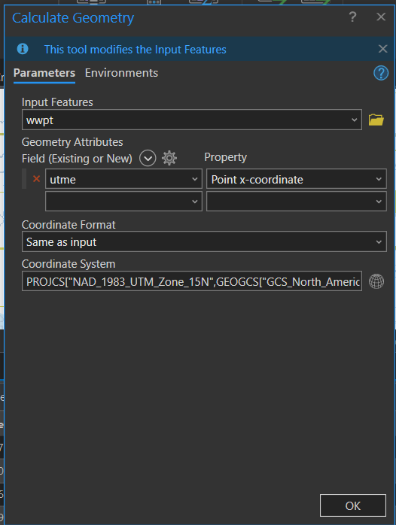

1. Make sure the “Coordinate System” is accurately identified and “Units” should be in Meters (m). Then click **OK**. This will recalculate the UTME and UTMN coordinates based on the current location of the well point(s)
2. Be sure to repeat the steps above for each swl_wwpt and dpl_wwpt (if available) associated with the relocated wwpt feature.

## Add New or Missing Wells

In some instances, wells are missing from the CWI database and need to be added manually.

Output files of the Unverified wells toolset MUST be used as templates. Run Unverified tools 2 and 3 before beginning. If no Unverified wells were within the buffer zone during the first run of the Unverified tool #2, increase buffer distance to grab at least one well.

### Manual Data Entry

The first step is to enter all of the required data into the respective tables and feature classes.

#### Create manual mapview well points

* Make a copy of the “wwpt_unloc” file and rename it “wwpt_unloc_manual”.
* Import or create the missing well points in “wwpt_manual”.
* Populate the following required fields for each record:
  + RELATEID, DEPTH_DRLL, UTME, UTMN, WELL_LABEL, XSEC_ID, BUFF_DIST, DEM
    - For coordinates, use Calculate Geometry as shown in the Edit Well Locations section above.
* When finished, click Save in the Edit ribbon.

#### Create manual mapview static water level points

* Make a copy of the “swl_unloc_clean” file and rename it “swl_unloc_manual”.
* Import or create the missing well points in “swl_manual”.
* Populate the following required fields for each record:
  + RELATEID, measuremt, meas_elev, UTME, UTMN, WELL_LABEL, XSEC_ID, BUFF_DIST, DEM
* When finished, click Save in the Edit ribbon.

#### Create manual strat table

* Make a copy of the “strat_unloc_clean” file and rename it “strat_unloc_manual”.
* Populate the following required fields after creating a row in the attribute table for each strat record for each well:
  + RELATEID, DRLLR_DESC, COLOR, LITH_PRIM, ELEV_TOP, ELEV_BOT, XSEC_ID, DEM
* When finished, click Save in the Edit ribbon.

#### Create manual construction table

* Make a copy of the “cons_unloc_clean” file and rename it “cons_unloc_manual”.
* Populate the following required fields for each construction record for each well:
  + RELATEID, CONSTYPE, XSEC_ID, BUFF_DIST, DEM, ELEV_TOP, ELEV_BOT
  + CONSTYPE: “C” - Casing, “G” - Grout, “H” - Open hole, “S” - Screen
* When finished, click Save in the Edit ribbon.

#### Create manual mapview drop pipe length points

* Make a copy of the “dpl_unloc_clean” file and rename it “dpl_unloc_manual”.
* Import or create the missing well points in “dpl_manual”.
* Populate the following required fields for each record:
  + RELATEID, DROPP_LEN, XSEC_ID, DEM
* When finished, click Save in the Edit ribbon.

### Running Tools

Run tools 4 through 6c in the UnverifiedWells toolset, using the updated Unloc_manual datasets created above as input parameters.

## Extras

This tool is optional to use and may provide helpful context to cross-sections.

### 7 Create Vertical Lines at Intersections

This tool plots vertical lines in cross section view at the locations of a cross section’s intersection with features such as roads, waterbodies, municipal or county boundaries, etc. You may either use and label the lines as they are, or temporarily use them to place annotation indicating the feature of interest.

This tool does not include features that are within the buffer zone that DO NOT cross the cross section line. If you would like to plot these features:

1. Create a new line feature class and digitize lines from the feature(s) of interest to the cross section line at a 90 degree angle. Make sure the line crosses or is snapped to the cross section line.
2. Be sure to add a “Name” field to the feature class and enter the feature’s name.
3. Run the Create Vertical Lines at Intersections tool.

#### Parameters

* Cross section line file (mapview): cross section lines in map view.
* Cross section line ID field: field in xsln that contains cross section number.
* Feature Class to Intersect: can be point, line, or polygon in mapview
* Vertical exaggeration factor: must match value used in other tools
* Output line feature class: name appropriately and save in the project’s default gdb.

#### Output

* Line feature class in 2D cross section view

##### Troubleshooting

* If the tool fails, it may be due to spaces or special characters in the Feature Class to Intersect’s name. Rename the layer in the table of contents and try running again.

## Formatting the Cross-sections

### Non-public Information

DNR has access to NON‐PUBLIC information for community water supplies in the CWI database file. DNR is NOT permitted to share this information with the public without the consent of the Minnesota Department of Health (MDH). Be sure to obscure the locations of these wells with polygons in your Map View before disseminating.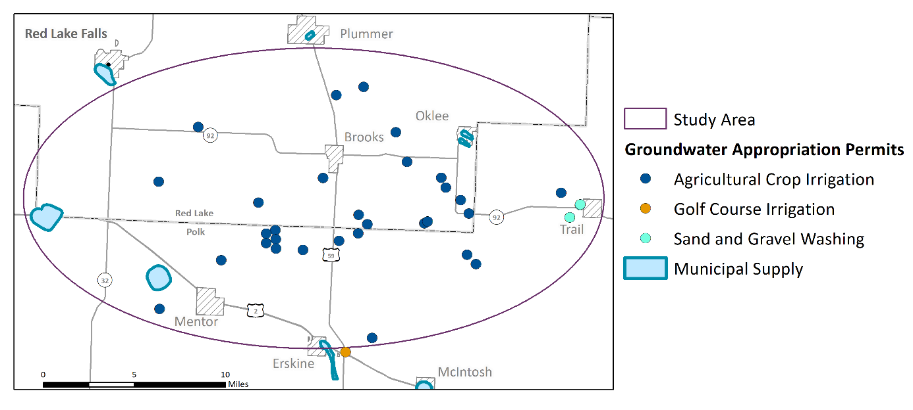

### Symbolize and label the wells in cross-section view

1. Right‐click on the “wwpt_2d_xsecview” file and select Symbology**.**
2. In the Symbology pane, click on the point symbol on the Primary symbology tab.
3. The Gallery will open. Go to the Properties tab of the Symbology pane. Change the shape colors to “no color” and click Apply.
4. Now click on the Labeling ribbon. On the left-hand side of the ribbon, check the box for “Label Features in this class”, and change the Field to ‘well_label’.
5. To center the well label above the well, and to orient it in the vertical direction, open the Label Placement menu.
6. In the Label Class pane, open the Position tab and expand the Placement header. Choose Top of Point for placement. Change the Preferred Offset to 5 points.
7. Now expand the Rotation header. Change the Additional Rotation value to 90.
8. In the Labeling ribbon, click on “View Unplaced” button to show unplaced labels.

### Format the well construction file

1. To format the well construction information, go to the table of contents, and click on symbol below the “conspys_2d_poly” file.
2. Change Primary Symbology to Unique Values, and Field 1 to “constype”

#### Caution!

* + Sometimes the well casing or screen information is missing from CWI. This can be very apparent when looking at the cross sections. If the well casings or well screens do not appear, you will need to go back and repeat some of the earlier steps. These include:
    - Opening up the cons_clean table and manually adding the casing, and screen information in the appropriate fields.
    - Rerunning the Create Conspy Diagrams tool to create a new set of conspy well stick files.
  + NOTE: This can be avoided if you carefully screen the cons_clean database tables prior to creating the conspy polygon files.

### Combine verified and unverified well lithology files

1. Open the “Merge” tool from the Geoprocessing pane. Add “lixpys_2d_poly” and “lixpys_unloc_2d_poly” as Input Datasets. Verify the output dataset is going to the correct location and is named appropriately.

### Format the verified well lithology file

1. Go to the table of contents and click on symbol below the “lixpys_2d_poly” file to open the Symbology menu.
2. Change Primary Symbology to Unique Values, and Field 1 to “lith_prim”.
3. Review the lith_prim values that appear. Some examples of naming issues to be aware of include:
4. Gravel may be spelled: GRAVEL, GRVL, GRVE, etc.
5. Combinations of lithology types may be reported as: Sand/Clay, Clay/Sand, Sand & Clay, Sandy Clay.
6. Be careful because SAND and SNDS are two different things! SNDS = Sandstone! *Remember, you can review the CWI naming schemes and codes on the* [*Minnesota County Well Index Database Dictionary Table: LTH_CODE webpage*](https://mgsweb2.mngs.umn.edu/cwi_doc/lth_code.asp)*.*
7. Create a field in the “lixpys_2d_poly” attribute table where you will edit or rename the lithologic layers to meet the needs of the project cross section. Name this field “INT_LITH” (for interpreted lithology) and set the **Field Type** to “Text”. This field can be modified to contain new names/ renamed lithologic layers using the **Editor** tool. Whichever name is selected, be consistent.
8. To modify the pattern fill or color, click on and format each of the colored boxes in the TOC. Modify the fill colors and patterns as desired. Note that the well construction outlines (casing, screen, etc.) will be laid over these lithology files but their transparency allows you to visualize the lithology. When finished, click on **Apply.**

#### Caution!

* Work with your Groundwater Specialist/ Professional Geoscientists on staff to determine how these lithologies should be renamed or grouped for the purposes of reporting names in the legends for the project cross section(s). Be clear and consistent with the language in the text of the report.

### Format the unverified well lithology file

Same instructions as for verified wells, except use “drllr_desc” field instead of “lith_prim”.

### Add the static water level elevations

1. Add “swl_2d_xsecview” to the TOC in the “Cross Section” map view.
2. Review these points to ensure that they are overlapping or slightly offset with your well sticks at the appropriate elevation.
3. These point files can be resymbolized as desired.

### Add the pump setting information

1. Add “dpl_2d_xsecview” to the TOC in the “Cross Section” map view.
2. Review these points to ensure that they are overlapping or slightly offset with your well sticks at the appropriate elevation.
3. These point files can be resymbolized as desired to highlight the elevations of pumps in groundwater wells.

### Create polylines or polygons to illustrate lithology

In addition to viewing the lithology in a well, you may also want to depict surface waterbodies, or to connect the sand or clay layers using lines or polygons.

* Create a new line or polygon Feature Class in your project geodatabase. Add the new file(s) to the Cross Section View map frame and digitize lines or polygons as needed.

Examples of how lines and polygons can be used to illustrate subsurface lithology are shown below.

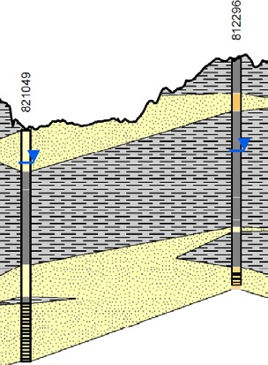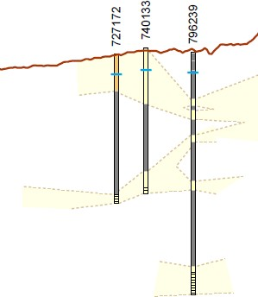

#### Caution!

* + Sometimes well sticks overlap. To move them, open an Edit session for lixpys_2d_poly in cross section view, select by RELATEID, then drag to the side with the editor tool and save your edits. Create annotation indicating which well was moved.
  + Lines connecting lithology in the wells should be dashed when the lithology between the wells is not clearly known.
  + Connecting the dots is not as easy as one might think. Geologic processes that would have deposited or formed the lithologic layers at this site will inform how you illustrate the cross-section lines.
  + In the State of Minnesota, all cross section that include geologic or hydrogeologic interpretations are required to be developed under a licensed Professional Geoscientist (PG).

### Format gridlines and axes

1. In the “Cross Section View” data frame, add the cross-section grid files (grid2011.gdb) from the geodatabase in the project folder. This geodatabase is also available here: I:\EWR\_IMA\HGG\_HYDRO_GEO_GROUNDWATER\Tools\GIS\Pro_DNR_CrossSection_Tool\GridFiles
2. Format the axes, axis labels and gridline per your preference.

#### Caution!

* + Elevations associated with the Y‐Axis are reported in feet while the horizontal distance from the start of the cross-section line as it appears on the X‐Axis is reported in meters. Modify accordingly.

### Format the legend

Remember that the file names may not be plain language. Please format the legend names so that they are clear and concise for the audience. Also make sure these labels are consistent with the text in any associated report.

### Format the Cross Section PDF

All cross sections should include:

* + Title
  + Legend
  + X and Y axes with labels
  + Vertical Exaggeration
  + Creator and Date Created
  + Map inset (or associated map view PDF)
    - Scale bar and north arrow

#### Accessibility

Due to the large amount of effort associated with making exported pdfs of the cross sections and maps accessible, it is recommended that these visuals be exported as JPGs from ArcMap. These JPGs can be added as images to Word documents. Adding Alt Txt to these images makes them accessible.

If using NAIP Imagery, Editing NAIP Imagery “MN DNR” text in Map Frame

* Ribbon – Insert
  + Dynamic Text
    - Layout subsection
      * Select “Service Layer Credits”, it should read MN DNR beneath it
        + Click anywhere to place the new Dynamic Text

MN DNR text should disappear from bottom corner

Service Layer Credits now shows up as a text item in the contents pane, can be moved around, edited, turned on/off, etc.

If text deleted from Contents Pane, default MN DNR text will reappear in bottom corner.